In GeoDa, run a regression by going to **Regression** -> **Regression**, as below:



Select the Dependent and Independent variables as below. First run OLS (or Classic) regression. Be sure to include the Weights File (this will give the Moran’s I of the residuals and the Lagrange Multiplier results at the bottom), and to specify that you want the White test for heteroscedasticity in the output.

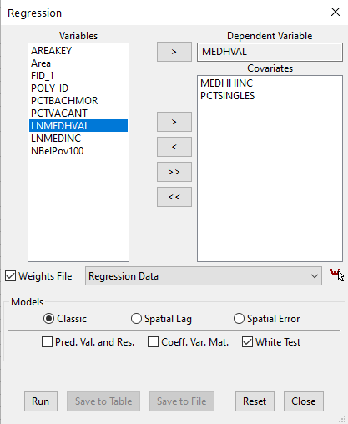

Click **Run** above. Get output below.

>>10/20/21 20:36:14

REGRESSION

----------

SUMMARY OF OUTPUT: ORDINARY LEAST SQUARES ESTIMATION

Data set : Regression Data

Dependent Variable : MEDHVAL Number of Observations: 1720

Mean dependent var : 66287.7 Number of Variables : 3

S.D. dependent var : 59988.6 Degrees of Freedom : 1717

R-squared : 0.433857 F-statistic : 657.9

Adjusted R-squared : 0.433197 Prob(F-statistic) : 0

Sum squared residual:3.50423e+012 Log likelihood : -20874.6

Sigma-square : 2.0409e+009 Akaike info criterion : 41755.2

S.E. of regression : 45176.4 Schwarz criterion : 41771.5

Sigma-square ML :2.03734e+009

S.E of regression ML: 45136.9

-----------------------------------------------------------------------------

Variable Coefficient Std.Error t-Statistic Probability

-----------------------------------------------------------------------------

CONSTANT -9320.58 2376.24 -3.92241 0.00009

MEDHHINC 2.29514 0.0732918 31.315 0.00000

PCTSINGLES 348.524 90.1592 3.86565 0.00011

-----------------------------------------------------------------------------

REGRESSION DIAGNOSTICS

MULTICOLLINEARITY CONDITION NUMBER 4.854904

TEST ON NORMALITY OF ERRORS

TEST DF VALUE PROB

Jarque-Bera 2 140594.6432 0.00000

DIAGNOSTICS FOR HETEROSKEDASTICITY

RANDOM COEFFICIENTS

TEST DF VALUE PROB

Breusch-Pagan test 2 6015.7227 0.00000

Koenker-Bassett test 2 266.6734 0.00000

SPECIFICATION ROBUST TEST

TEST DF VALUE PROB

White 5 379.2413 0.00000

DIAGNOSTICS FOR SPATIAL DEPENDENCE

FOR WEIGHT MATRIX : Regression Data

(row-standardized weights)

TEST MI/DF VALUE PROB

Moran's I (error) 0.4505 32.0629 0.00000

Lagrange Multiplier (lag) 1 1058.4430 0.00000

Robust LM (lag) 1 158.6624 0.00000

Lagrange Multiplier (error) 1 1016.4530 0.00000

Robust LM (error) 1 116.6724 0.00000

Lagrange Multiplier (SARMA) 2 1175.1154 0.00000

============================== END OF REPORT ================================

Click **Save to Table**, and in the **Save Regression Results** pop up, click **OK**. You now have two new columns in your attribute table, *OLS_PREDIC* (OLS y-hats) and *OLS_RESIDU* (OLS Residuals).

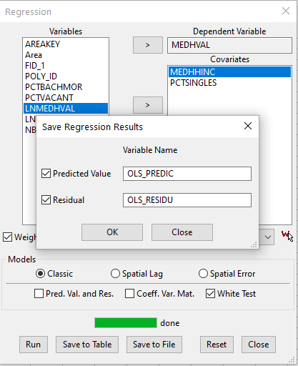

Now, let’s look at spatial autocorrelation in OLS residuals two different ways.

The first is by examining the Moran’s I of the OLS residuals



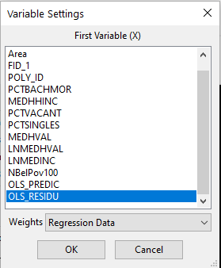

You get the output below:

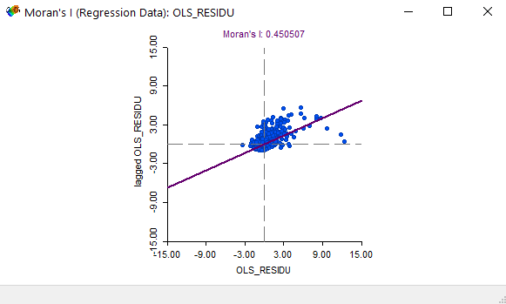

You can now run 999 random permutations by right-clicking in the Moran’s scatterplot above and selecting **999 Permutations** under **Randomization:**

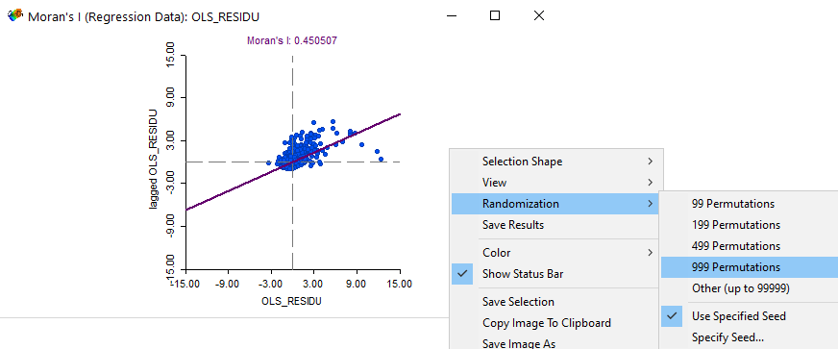

The output is below – we see that there is significant spatial autocorrelation in the OLS residuals.

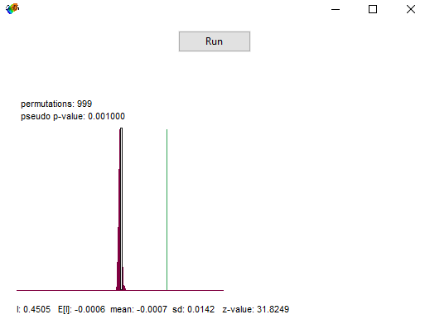

The second way to examine residuals for spatial autocorrelation is to regress them on their neighbors. If residuals are random, they won’t be related to their neighbors. If residuals aren’t random and are spatially autocorrelated, then there will be a relationship between OLS residuals and nearby (i.e., lagged) OLS residuals.

To do this, let’s create the lagged OLS residual variable. Go to the **Table** menu and select **Add Variable**.

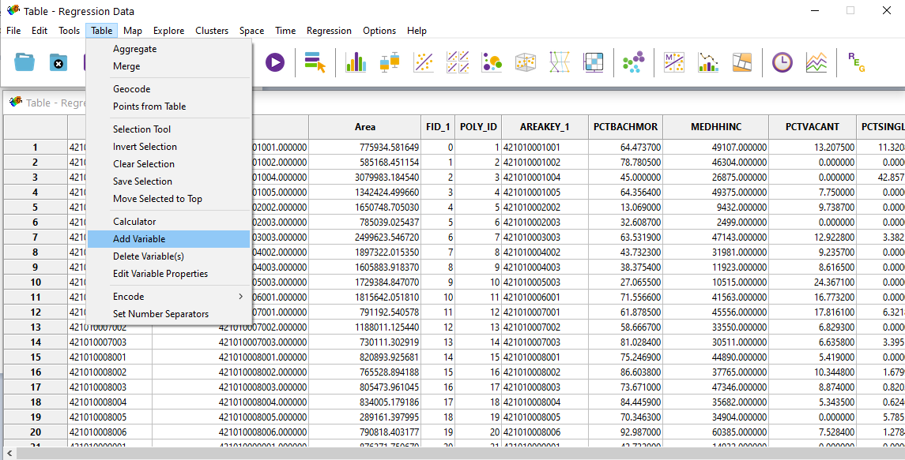

Name the variable *LAG_OLSRES*, and insert it after the last variable, as shown below:

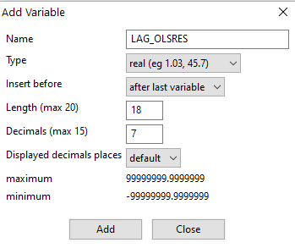

Then, in the Table, right-click on the *LAG_OLSRES* variable, and select **Calculator**, as shown below:

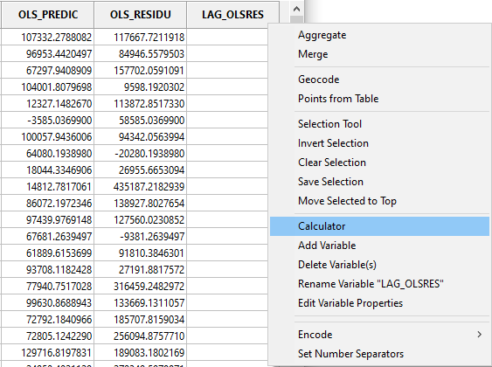

In the **Spatial Lag** tab, calculate the *LAG_OLSRES* variable as demonstrated below:

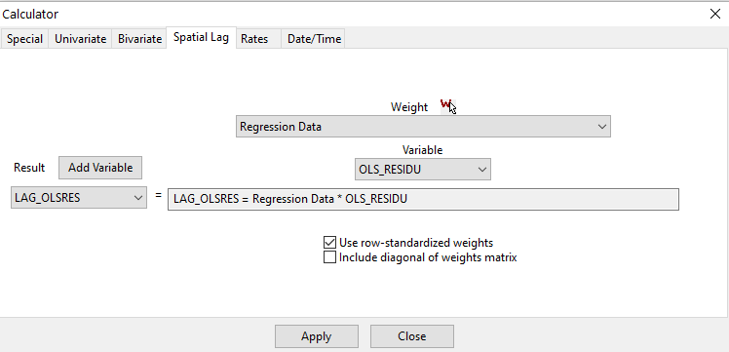

Now that the variable has been calculated, regress *OLS_RESIDU* on *LAG_OLSRES*:

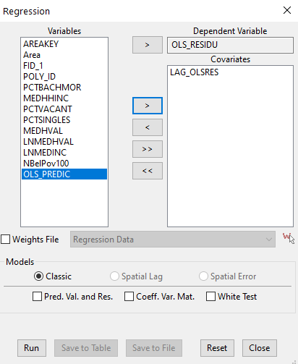

The output is below. We can see that the *LAG_OLSRES* term has a beta coefficient (also known as lambda) that is strongly significant. Here, we see that there’s a strong association between OLS residuals and lagged (i.e., nearby) OLS residuals. Just like Moran’s I, this shows that there’s significant spatial autocorrelation in OLS residuals, and we need to run a spatial regression.

>>10/20/21 21:02:24

REGRESSION

----------

SUMMARY OF OUTPUT: ORDINARY LEAST SQUARES ESTIMATION

Data set : Regression Data

Dependent Variable : OLS_RESIDU Number of Observations: 1720

Mean dependent var :5.23044e-011 Number of Variables : 2

S.D. dependent var : 45136.9 Degrees of Freedom : 1718

R-squared : 0.371895 F-statistic : 1017.21

Adjusted R-squared : 0.371529 Prob(F-statistic) : 0

Sum squared residual:2.20103e+012 Log likelihood : -20474.7

Sigma-square :1.28116e+009 Akaike info criterion : 40953.3

S.E. of regression : 35793.2 Schwarz criterion : 40964.2

Sigma-square ML :1.27967e+009

S.E of regression ML: 35772.4

-----------------------------------------------------------------------------

Variable Coefficient Std.Error t-Statistic Probability

-----------------------------------------------------------------------------

CONSTANT -818.094 863.433 -0.947491 0.34353

LAG_OLSRES 0.825503 0.0258829 31.8937 0.00000

-----------------------------------------------------------------------------

REGRESSION DIAGNOSTICS

MULTICOLLINEARITY CONDITION NUMBER 1.030162

TEST ON NORMALITY OF ERRORS

TEST DF VALUE PROB

Jarque-Bera 2 256215.3394 0.00000

DIAGNOSTICS FOR HETEROSKEDASTICITY

RANDOM COEFFICIENTS

TEST DF VALUE PROB

Breusch-Pagan test 1 1339.6627 0.00000

Koenker-Bassett test 1 43.8786 0.00000

============================== END OF REPORT ================================

To run the spatial lag (or spatial error) regression, go back to the Regression menu, and select the spatial model you want:

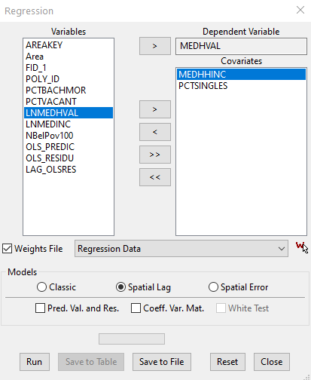

After running the regression and copying the output, once again, click on **Save to Table**, and save the Predicted Values and Residuals to the Table. You will be able to look at the Moran’s I of the Spatial Lag (or Spatial Error) residuals the same way you did for OLS residuals above.